# Homework 3:

Linear Regression and Logistic Regression

[Data Mining and Machine Learning (March 2022)](http://www.sysu.edu.cn/)

Student Name: Student ID:

Lectured by: Shangsong Liang Sun Yat-sen University

Deadline of your submission is: 10:10 AM, March 29, 2022

**Do NOT Distributed This Document and the Associated Datasets**

1. **Exercise One: Linear Regression**

In this homework, you will investigate multivariate linear regression using Gradient Descent and Stochas- tic Gradient Descent. 1 You will also examine the relationship between the cost function, the convergence of gradient descent, overfitting problem, and the learning rate.

在本次作业中，你将探讨使用梯度下降法和随机梯度下降法的多变量线性回归模型。你将探讨损失函数、 梯度下降法的收敛、过拟合问题和学习率等之间的关系。

Download the file “dataForTrainingLinear.txt”in the attached files called “Assignment 3”. This is a training dataset of apartment prices in Haizhu District, Guangzhou, Guangdong, China, where there are 50 training instances, one line per one instance, formatted in three columns separated with each other by a whitespace. The data in the first and the second columns are sizes of the apartments in square meters and the distances to the Double-Duck-Mountain Vocational Technical College in kilo-

meters, respectively, while the data in the third are the corresponding prices in billion RMB. Please build a multivariate linear regression model with the training instances by script in any programming languages to predict the prices of the apartments. For evaluation purpose, please also download the file “dataForTestingLinear.txt”(the same format as that in the file of training data) in the same folder.

请在文件夹“Assignment 3”中下载文件名为“dataForTrainingLinear.txt”的文件。该文件包含广东省广州市海珠区的房价信息，里面包含 50 个训练样本数据。文件有三列，第一列对应房的面积（单位：平方米），第二列对应房子距离双鸭山职业技术学院的距离（单位：千米），第三列对应房子的销售价格（单位：元）。每一行对应一个训练样本。请使用提供的 50 个训练样本来训练多变量回归模型以便进行房价预测，请用（随机）梯度下降法的多变量线性回归模型进行建模。为了评估训练效果，请文件夹中下载测试数据集“dataForTestingLinear.txt”（该测试文件里的数据跟训练样本具有相同的格式，即第一列对应房子面积，第二列对应距离，第三列对应房子总价）。

1. How many parameters do you use to tune this linear regression model? Please use Gradient De- scent to obtain the optimal parameters. Before you train the model, please set the number of iterations to be 1500000, the learning rate to 0.00015, the initial values of all the parameters to 0.0. During train- ing, at every 100000 iterations, i.e., 100000 , 200000,⋯, 1500000, report the current training error and the testing error in a figure (you can draw it by hands or by any software). What can you find in the plots? Please analyze the plots.

你需要用多少个参数来训练该线性回归模型？请使用梯度下降方法训练。训练时，请把迭代次数设成1500000，学习率设成 0.00015，参数都设成 0.0。在训练的过程中，每迭代 100000 步，计算训练样本对应的误差，和使用当前的参数得到的测试样本对应的误差。请画图显示迭代到达 100000 步、200000 步、

⋯⋯1500000 时对应的训练样本的误差和测试样本对应的误差（图可以手画，或者用工具画图）。从画出

1To see what are “Gradient Descent” and “Stochastic Gradient Descent”, please refer to the slides “linear_model.pptx”.

1要了解什么是“梯度下降”和“随机梯度下降”，请参阅幻灯片“linear_model.pptx”。

的图中，你发现什么？请简单分析。

1. Now, you change the learning rate to a number of different values, for instance, to 0.0002 (you may also change the number of iterations as well) and then train the model again. What can you find? Please conclude your findings.

现在，你改变学习率，比如把学习率改成 0.0002（此时，你可以保持相同的迭代次数也可以改变迭代次数），然后训练该回归模型。你有什么发现？请简单分析。

1. Now, we turn to use other optimization methods to get the optimal parameters. Can you use Stochas- tic Gradient Descent to get the optimal parameters? Plots the training error and the testing error at each K-step iterations (the size of K is set by yourself). Can you analyze the plots and make comparisons to those findings in Exercise 1?

现在，我们使用其他方法来获得最优的参数。你是否可以用随机梯度下降法获得最优的参数？请使用随机梯度下降法画出迭代次数（每 K 次，这里的 K 你自己设定）与训练样本和测试样本对应的误差的图。比较 Exercise 1 中的实验图，请总结你的发现。

1. **Exercise Two: Logistic Regression**

You will implement a logistic regression classifier and apply it to a two-class classification problem. To get started, download the two datasets, “dataForTrainingLogistic.txt” and “dataForTestingLogistic.txt” from the folder called “Assignment 3”. In both of these two datasets, each instance is put per line with the first to the six columns being the features of the instance and the last column being the ground-truth label of the category (either “1” or “0”) that the instance should be classified into. Each column per line is separated by a whitespace.

您将实现逻辑回归分类器并将其应用于二分类问题。 首先，从名为“Assignment 3”的文件夹中下载两个数据集“dataForTrainingLogistic.txt”和“dataForTestingLogistic.txt”。 在这两个数据集中，每个实例都按行放置，第一到六列是实例的特征，最后一列是类别的真实标签（“1”或“0”） 实例应分类为。 每行的每一列由一个空格分隔。

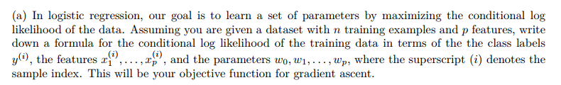

(a) 在逻辑回归中，我们的目标是通过最大化数据的条件对数似然来学习一组参数。 假设您有一个包含 n 个训练示例和 p 个特征的数据集，请根据类标签 y(i)、特征 x(i)、... 写下训练数据的条件对数似然的公式。 . . , x(i) 和参数 w , w , . . . , w , 其中上标 (i) 表示样本索引。 这将是梯度上升的目标函数。

（b）Compute the partial derivative of the objective function with respect to *w*0 and with respect to an arbitrary *wj*, i.e. derive *∂f* /*∂w*0 and *∂f* /*∂wj*, where *f* is the objective that you provided above. Please show all derivatives can be written in a finite sum form.

(b) 计算目标函数关于 w0 和任意 wj 的偏导数，即导出 ∂f /∂w0 和 ∂f /∂wj，其中 f 是您在上面提供的目标。 请证明所有导数都可以写成有限和形式。

（c）Train your logistic regression classifier on the data provided in the training dataset “dataForTrain- ingLogistic.txt”. How do you design and train your logistic regression classifier? What are your optimal estimated parameters in your logistic regression classifier? Use your estimated parameters to calculate predicted labels for the data in the testing dataset “dataForTestingLogistic.txt” (Do not use the label information (the last column in the file) for testing).

（c）根据训练数据集“dataForTrainingLogistic.txt”中提供的数据训练逻辑回归分类器。 你如何设计和训练你的逻辑回归分类器？ 您的逻辑回归分类器中的最佳估计参数是什么？ 使用您的估计参数计算测试数据集“dataForTestingLogistic.txt”中数据的预测标签（不要使用标签信息（文件中的最后一列）进行测试）。

（d）Report the number of misclassified examples in the testing dataset.

（d）报告测试数据集中错误分类示例的数量。

（e）Plot the value of the objective function on each iteration of stochastic gradient ascent, with the iter- ation number on the horizontal axis and the objective value on the vertical axis. Make sure to include axis labels and a title for your plot. Report the number of iterations that are required for the algorithm to converge.

（e）绘制随机梯度上升每次迭代的目标函数值，横轴为迭代次数，纵轴为目标值。 确保包含轴标签和绘图的标题。 报告算法收敛所需的迭代次数。

（f）Next, you will evaluate how the training and test error change as the training set size increases. For each value of *k* in the set 10*,* 20*,* 30*, . . . ,* 380*,* 390*,* 400 , first choose a random subset of the training data of size *k*. Then re-train your logistic regression classifier using the *k* random subset of the training data you just chose, and use the estimated parameters to calculate the number of misclassified examples on both the current training set (*k* random instances) and on the original test set “dataForTestingLogistic.txt”. Finally, generate a plot with two lines: in blue, plot the value of the training error against *k*, and in red, plot the value of the test error against *k*, where the error should be on the vertical axis and training set

*{ }*

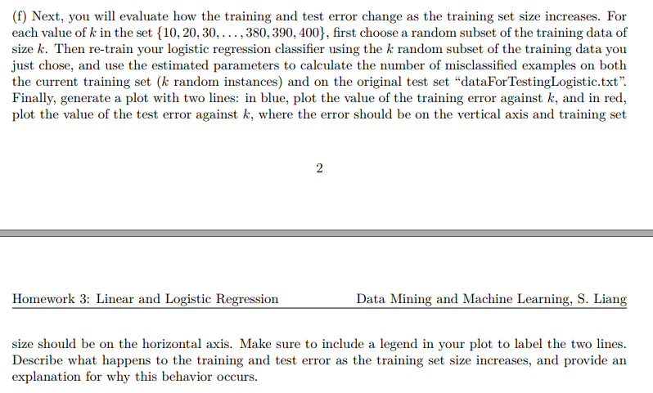

（f）接下来，您将评估训练和测试误差如何随着训练集大小的增加而变化。 对于集合 10, 20, 30, 中的每个 k 值。 . . , 380, 390, 400 ，首先选择大小为 k 的训练数据的随机子集。 然后使用您刚刚选择的训练数据的 k 个随机子集重新训练您的逻辑回归分类器，并使用估计的参数来计算当前训练集（k 个随机实例）和原始测试集上的错误分类示例数 “dataForTestingLogistic.txt”。 最后，生成一个包含两条线的图：蓝色表示训练误差值与 k 的关系，红色表示测试误差值与 k 的关系，其中误差应位于垂直轴和训练集上

size should be on the horizontal axis. Make sure to include a legend in your plot to label the two lines. Describe what happens to the training and test error as the training set size increases, and provide an explanation for why this behavior occurs.